Circulatory System Terminology
Blood
Plasma: _________________________________________________________ ________________________________________________________________
Red blood cells: ___________________________________________________ ________________________________________________________________
White blood cells: _________________________________________________ ________________________________________________________________
Platelets: ________________________________________________________ ________________________________________________________________
Oxygenated: _____________________________________________________ ________________________________________________________________
Deoxygenated: ___________________________________________________ ________________________________________________________________
Blood Vessels
Arteries: _________________________________________________________ ________________________________________________________________
Veins: ___________________________________________________________ ________________________________________________________________
Capillaries: _______________________________________________________ ________________________________________________________________
Valves: __________________________________________________________ ________________________________________________________________
Lumen: __________________________________________________________ ________________________________________________________________

- Identify the following blood vessels.
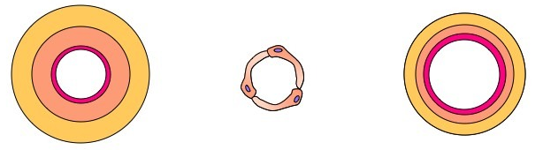
_______________ ________________ _______________
- In the box provided, draw the side on view for each blood vessel.
Draw valves in the blood vessel(s) that contain valves.

- Compare the size of the lumen for each blood vessel.
The lumen of the arteries are _____________________________________________ _______________________________________________________________________________________________________________________________________________________________________________________________________________

